Neo- Enigma User Manual

Neo-Enigma is an encryption and decryption program, which gives you the ability to share top secret or private information amongst friends, clients, etc.

Neo-Enigma is a highly secure program with strong and unique encryption algorithm. It works based on a duel key system, which allows every encrypted message to be unique and more secure.

Program Requirements

Any machine running java will be able to run this program.

Setup

Begin by opening the Neo-Enigma program folder. From there, click on the program’s jar file (should have a white, blue and orange java icon). After clicking on the file, the program should appear and you are all ready to begin using the Neo-Enigma program.

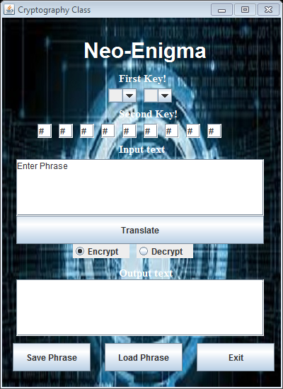Main Page GUI Diagram

Input box for encrypted and decrypted text

Encrypt and decrypt radio buttons

Save, load and exit buttons

Output box for encrypted and decrypted text

Button to encrypt or decrypt

Second Key text fields

First Key Selection Boxes

Open and Save File Chooser Diagrams

New folder

Go to Home Directory

Up Level

Drop down menu to set location to look in

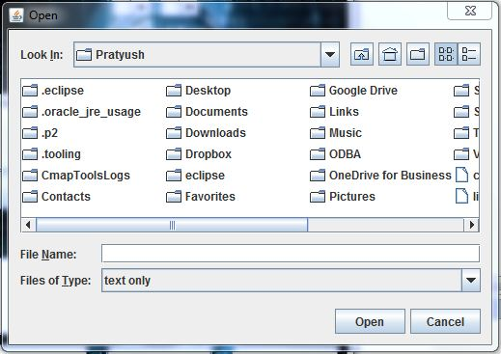

Open and cancel buttons

Text field for file name

Display frame for files in directory

Set file arrangement

New folder

Drop down menu to set location to look in

Up Level

Go to Home Directory

Set file arrangement

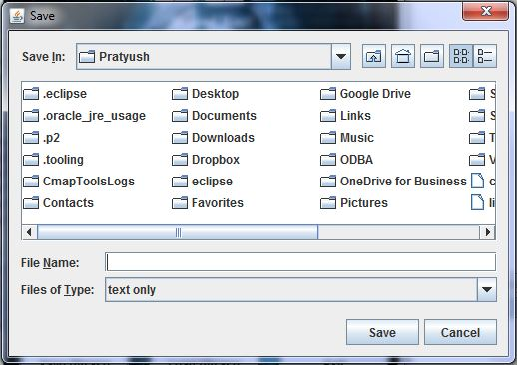

Display frame for files in directory

Text field for file name

Save and cancel buttons

How to Encrypt

Manual Encryption:

1) Use the two dropdown keys to select the first key.

2) Fill all the nine boxes with integers (from 0 - 40) to create your second key.

a) All boxes must be filled.

b) Do not use special characters. (Special characters include "%", "#", "!", ",", ".", "?", "/", etc.)

c) Do not input decimal numbers.

3) Enter a message to be encrypted in the text box.

4) Click on the encrypt radio button

5) Click on "Translate".

6) Encryption version of the message will appear in the box below.

Loading a Regular Text File for Encryption:

1) Click on “Load”

2) Select “Normal Message”

3) Find and select the file you want to open

4) Click “Open”

3) Next, use the dropdown menu to select the first key.

4) Fill all the nine boxes with integers (from 0 - 40) to create your second key.

a) All boxes must be filled.

b) Do not use special characters. (Special characters include "%", "#", "!", ",", ".", "?", "/", etc.)

c) Do not input decimal numbers.

6) Click on "Translate".

7) The encrypted version of the loaded message will appear in the textbox below.

How to Relay Encrypted Messages

Manual Method (Less secure):

1) Record the first key.

2) Record the second key.

3) Record encrypted message.

4) Give the desired recipient these 3 pieces of information manually.

Digital Method (Recommended)

1) Click on "Save".

3) Look through the directories to find where you want to save your file

2) Once finding a location to save, enter the name you want to save the file by. (exclude ".txt")

3) Click on “Save” in the file chooser.

3) Two files will be created in the specified directory, one with the encrypted text and the other with the encrypted key (\*fileName\*.txt and \*fileName\*key.txt)

4) You can now safely and securely send both the encrypted text and key files to your intended recipient. The program will automatically decrypt the key when loading so only the encrypted text and key file need to be sent.

How to Decrypt Messages

Manual Decryption:

1) Set the 2 digit first key that was provided by the person sending the message.

2) Enter the nine digit key that should have also been provided by the person sending the message.

3) Enter the encrypted message in the text box.

4) Click on the decrypt radio button

5) Click "Translate".

Loading and Encrypted Text File for Decryption:

1) Select “load” (Diagram of main GUI can be found on first page)

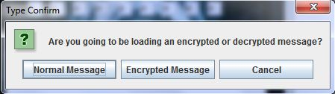2) Select "Encrypted Message"

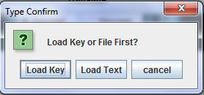3) Either select “load key” or “load phrase”

a) If loading the key file first, look for and select the key file in directory and click “open”. (Key file will be called: \*fileName\*key.txt)

b) If loading the text file first, look for and select the text file in the directory and click “open”.

4) You will now be given the option to enter either the key or text file (whichever one has not been loaded). You can either click “later” to return back to the main page and enter the text later or you can choose to continue and click “load text” or “load key” to load the remaining key or text file.

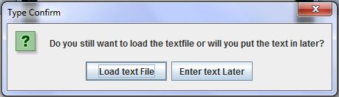

5) If you chose to either load the key or text file, to load again, follow the same instructions that helped load the previous file.

6) Next, click on "Translate"

7) The decrypted message will be shown in the bottom box.